Dharma Devi 24th April HW

[Google Colab](https://colab.research.google.com/drive/1f3_2ea8hFge7e05JOnc9IYEzNqkG1htM?usp=sharing)

Ingestion

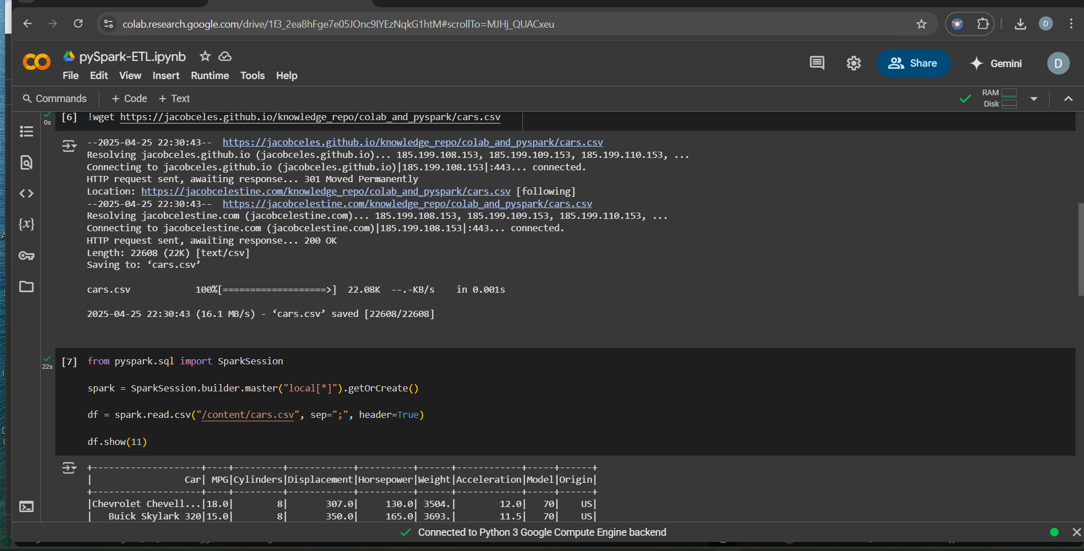

Transform and Load

